**MA4832 Microprocessor Systems**

**Lab 2 Exercise – Hardware – Pushbutton SW 1 and RGB LED**

**You will learn in this session:**

* How to read digital signal from input device through GPIO port F (read the Status of SW1 on PF4)
* How to send digital signal to output device through GPIO port F (turn on LED, Red (PF1), Blue (PF2) and Green (PF3))

**Hardware Connection:**

Please follow the diagram below to do the hardware connection among TM4C123GH6P, three LEDs and two switches. Once done, please approach the lab Technician for verification.

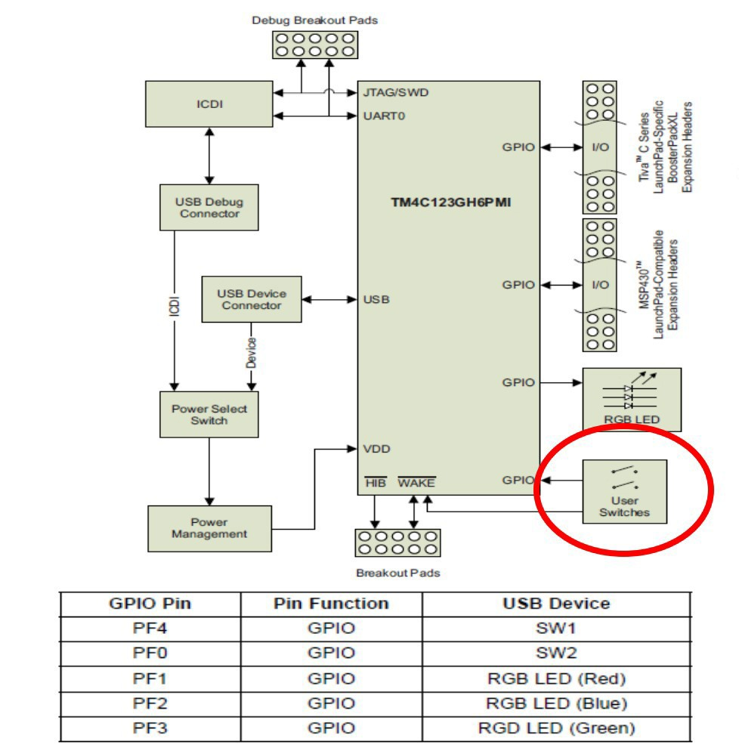



1. Program to read the status of SW1 and turn on and off the LED (white)

* Program: main.s

GPIO_PORTF_DATA_R EQU 0x400253FC ; set bit to 1 for Bits 9:2

GPIO_PORTF_DIR_R EQU 0x40025400

GPIO_PORTF_AFSEL_R EQU 0x40025420

GPIO_PORTF_PUR_R EQU 0x40025510

GPIO_PORTF_DEN_R EQU 0x4002551C

GPIO_PORTF_AMSEL_R EQU 0x40025528

GPIO_PORTF_PCTL_R EQU 0x4002552C

PF0 EQU 0x40025004 ; SW2 - negative logic

PF1 EQU 0x40025008 ; RED LED

PF2 EQU 0x40025010 ; BLUE LED - ORIG

PF3 EQU 0x40025020 ; GREEN LED

PF4 EQU 0x40025040 ; SW1 - ORIG -negative logic

PFA EQU 0x40025038 ; All 3 colours (RGB)- white

SYSCTL_RCGCGPIO_R EQU 0x400FE608 ; Register to enable port F .p340

AREA |.text|, CODE, READONLY, ALIGN=2

THUMB

EXPORT Start

Start

; initialize PF 1-3 output, PF4 an input,

; enable digital I/O, ensure alt. functions off.

; Input: none, Output: none, Modifies: R0, R1

; activate clock for Port F

LDR R1, =SYSCTL_RCGCGPIO_R

LDR R0, [R1]

ORR R0, R0, #0x20 ; set bit 5 to turn on clock

STR R0, [R1]

NOP ; allow time for clock to finish

NOP

NOP

; no need to unlock PF2

; disable analog functionality

LDR R1, =GPIO_PORTF_AMSEL_R

LDR R0, [R1]

BIC R0, #0x0E ; 0 means analog is off

STR R0, [R1]

;configure as GPIO

LDR R1, =GPIO_PORTF_PCTL_R

LDR R0, [R1]

BIC R0, R0, #0x00000FF0 ; Clears bit 1 & 2 (to ensure default GPIO func selected)

BIC R0, R0, #0x000FF000 ; Clears bit 3 & 4 (to ensure default GPIO func selected)

STR R0, [R1]

;set direction register

LDR R1, =GPIO_PORTF_DIR_R

LDR R0, [R1]

ORR R0, R0, #0x0E ; PF 1,2,3 output (1 in output)

BIC R0, R0, #0x10 ; Make PF4 built-in button input (0 is output)

STR R0, [R1]

; regular port function

LDR R1, =GPIO_PORTF_AFSEL_R

LDR R0, [R1]

BIC R0, R0, #0x1E ; 0 means disable alternate function

STR R0, [R1]

; pull-up resistors on switch pins

LDR R1, =GPIO_PORTF_PUR_R ; R1 = &GPIO_PORTF_PUR_R

LDR R0, [R1] ; R0 = [R1]

ORR R0, R0, #0x10 ; R0 = R0|0x10 (enable pull-up on PF4)

STR R0, [R1] ; [R1] = R0

; enable digital port

LDR R1, =GPIO_PORTF_DEN_R ; 7) enable Port F digital port

LDR R0, [R1]

ORR R0,#0x0E ; 1 means enable digital I/O

ORR R0, R0, #0x10 ; R0 = R0|0x10 (enable digital I/O on PF4)

STR R0, [R1]

LDR R4, =PF4 ; R4 = &PF4

loop ; in this loop, the appliance (PF2) toggles when the switch

; is released

BL SSR_On

waitforpress1 ; proceed only when the button is pressed

LDR R0, [R4] ; R0 = [R4] (read status of PF4)

CMP R0, #0x10 ; R0 == 0x10?

BEQ waitforpress1 ; if so, spin

waitforrelease1 ; proceed only when the button is released

LDR R0, [R4] ; R0 = [R4] (read status of PF4)

CMP R0, #0x10 ; R0 != 0x10?

BNE waitforrelease1 ; if so, spin

BL SSR_Off

waitforpress2 ; proceed only when the button is pressed

LDR R0, [R4] ; R0 = [R4] (read status of PF4)

CMP R0, #0x10 ; R0 == 0x10?

BEQ waitforpress2 ; if so, spin

waitforrelease2 ; proceed only when the button is released

LDR R0, [R4] ; R0 = [R4] (read status of PF4)

CMP R0, #0x10 ; R0 != 0x10?

BNE waitforrelease2 ; if so, spin

B loop

;------------SSR_On------------

; Make PFA high.

; Input: none

; Output: none

; Modifies: R0, R1

SSR_On

LDR R1, =PFA ; R1 = &PFA

MOV R0, #0x0E ; R0 = 0x04 (turn on the appliance)

STR R0, [R1] ; [R1] = R0, write to PFA

BX LR ; return

;------------SSR_Off------------

; Make PFA low.

; Input: none

; Output: none

; Modifies: R0, R1

SSR_Off

LDR R1, =PFA ; R1 = &PFA

MOV R0, #0x00 ; R0 = 0x00 (turn off the appliance)

STR R0, [R1] ; [R1] = R0, write to PFA

BX LR ; return

ALIGN ; make sure the end of this section is aligned

END ; end of file

* Load and run the program.
* Study the code and determine;
  + - * 1. How status of SW1 (PF4) is read when it is pressed and released.
        2. How the LED (White) is generated and then turned off.

**Exercise:**

Modify the code such that with each successive press and release of switch SW1

* The TM4C123G LED will perform the following operation.

Press SW1 - Red Led

Press SW1 – Off

Press SW1 – Blue Led

Press SW1 – Off

Press SW1 - Green Led

Press SW1 – Off

Press SW1 - White Led

Press SW1 – Off

Repeat.